Verb Complement

✅ What Is a Verb Complement?
# Source: AI Source: Provided by: [Data Path: Persons Table -> ID Column: 1, Name_En Column: Motasem Essam] -> From: [ChatGPT] on [8/4/2025]
A Verb Complement is a word or phrase that is necessary to complete the meaning of a verb.
It typically answers “what?” or “whom?” after the verb and may include objects, infinitives, gerunds, or noun clauses.

🔸 Key Features:
# Source: AI Source: Provided by: [Data Path: Persons Table -> ID Column: 1, Name_En Column: Motasem Essam] -> From: [ChatGPT] on [8/4/2025]
- Directly follows the main verb
- Completes or specifies the action or idea
- Can be:
  - A noun phrase
  - An infinitive or gerund
  - A clause (often a that-clause)
- Found with verbs like:
want, like, tell, help, make, think, know, believe, prefer, advise

🔸 Types of Verb Complements and Examples:
# Source: AI Source: Provided by: [Data Path: Persons Table -> ID Column: 1, Name_En Column: Motasem Essam] -> From: [ChatGPT] on [8/4/2025]
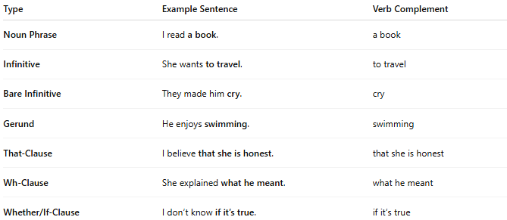
Type | Example Sentence | Verb Complement
Noun Phrase | I read a book. | a book
Infinitive | She wants to travel. | to travel
Bare Infinitive | They made him cry. | cry
Gerund | He enjoys swimming. | swimming
That-Clause | I believe that she is honest. | that she is honest
Wh-Clause | She explained what he meant. | what he meant
Whether/If-Clause | I don’t know if it’s true. | if it’s true

🔸 Comparison – Verb Complement vs Object:
# Source: AI Source: Provided by: [Data Path: Persons Table -> ID Column: 1, Name_En Column: Motasem Essam] -> From: [ChatGPT] on [8/4/2025]
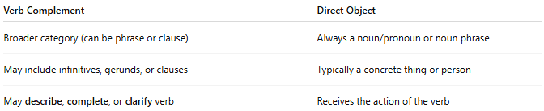
Verb Complement | Direct Object
Broader category (can be phrase or clause) | Always a noun/pronoun or noun phrase
May include infinitives, gerunds, or clauses | Typically a concrete thing or person
May describe, complete, or clarify verb | Receives the action of the verb

🔸 Tip to Identify a Verb Complement:
# Source: AI Source: Provided by: [Data Path: Persons Table -> ID Column: 1, Name_En Column: Motasem Essam] -> From: [ChatGPT] on [8/4/2025]
- Ask: What completes the verb’s meaning?
- Check for infinitives, gerunds, or clauses following the verb.
- Without it, the verb feels incomplete.

